Expanding Business Into Jamaica
Name of Student
Institution affiliation

Expanding Business Into Jamaica
Introduction
Jamaica is an island country located in the Caribbean Sea, and it consists of the third-largest island in the Greater Antilles. Jamaica is 10,990 square kilometers in area, and it lies about 145 kilometers south of Cuba, and 191 kilometers west of Haiti and Dominican Republic. The primary language spoken in Jamaica is an English-based creole known as the Jamaican Patois. The Patois language spoken by Jamaicans is influenced by languages of West and Central Africa. It also has influences from various dialects of English, particularly those of Ireland and Scotland. The official language of Jamaica is the Jamaican Standard English, and it is used in all domains of public life including the government, the media, the legal system, and education. The Jamaican culture is mixed as it consists of an ethnically diverse society which stems from a history of inhabitants beginning with the original Taino people. The black slaves became the dominant cultural force, particularly because they suffered, and consequently resisted the harsh conditions of forced labor. After the abolition of slavery, the Indian and Chinese migrants brought them the ideas from the Far East which significantly influenced the Jamaican culture. Religion is fundamental to the people of Jamaica. They are mostly Christians, and refer to Biblical events in their everyday speech. The island has the highest number of churches per capita globally with 100 different Christian denominations. The primary currency used in Jamaica is the Jamaican Dollar. The Jamaican politics take place in the framework of a representative parliamentary constitutional monarchy with the head of state being Queen Elizabeth II. However, the constitution vests executive power in the cabinet. The cabinet is led by the Prime Minister. Jamaica presents a favorable business location with a significant potential for success. This paper will give an in-depth analysis Jamaica as a suitable location into which the business should expand.
Economic Conditions
Jamaica is an upper middle-income country in the English-speaking Caribbean with the largest population. Jamaica had to struggle with low economic growth for decades due to high public debts as well as many external shocks that weakened the economy further. The real income per capita has been increasing at an average of 1 percent over the last thirty years, making it one of the slowest-growing developing countries in the world. However, the government of Jamaica has undergone comprehensive and ambitious program of reforms that have attracted both national and international support (Boussebaa, 2015). Moreover, the Jamaican government has received funding from the World Bank, the Inter-American Development Bank and the International Monetary Fund in order to facilitate the national economic growth. Furthermore, the International Finance Corporation and the Multilateral Investment Guarantee Agency have also continued to support the private sector development in Jamaica. A change in administration after the February 2016 general elections has brought a further consolidation of government efforts with a dedicated Ministry of Economic Growth and Job Creation which is headed by the Prime Minister.
The economic reform in Jamaica has begun to bear positive results as institutional reforms and measures have been implemented with the objective of improving the environment for the private sector. Such concerted efforts have helped to significantly restore confidence in the Jamaican economy (Johnston & Montecino, 2012). Jamaica ranked for a second year in a row among the top ten progressive countries worldwide in the 2016 Doing Business Report. Additionally, the country’s credit rating has significantly improved, and the Jamaican bonds are trading at a premium rate in the international markets. The government has initiated effective macroeconomic policies which are necessary for improving the growth of the economy.
Foreign direct investment flows to Jamaica have been increasing in the recent years. In 2014, the foreign direct investment flows to Jamaica amounted to more than $550 million. Moreover, the foreign direct investment flows had grown by 30 percent by the end of 2016. It shows that the government has implemented policies that are friendly towards foreign direct investments. The government of Jamaica has significantly encouraged foreign direct investments by offering incentives such as payment facilities, duty-free imports to foreign investors, and grace periods for tax payments (Heritage Foundation, 2017). This indicates that it is worth expanding one’s business into Jamaica in order to take advantage of the incentives offered by the Jamaican government. Additionally, Jamaica’s inflation has continued to decline, with the figure expected to fall to 2.3 percent by the end of April 2017. Such an inflation rate is not harmful given that the country’s economy is still recovering from the debt crisis. It is important to realize that the country has many assets including the rich natural resources as well as a significant capacity to receive large numbers of tourists. Although there is drug trafficking and significant levels of criminality, Jamaica still presents a favorable destination for foreign direct investment because the government is committed to providing a good environment for the private sector.
In addition, the country plans to become a logistical hub between North America and South America. This objective requires the development of transport infrastructure such as aviation, maritime, rail and road one as well as logistics (Korbee et al., 2015). The country has already initiated projects aimed at achieving the objective. As such, it is important to expand the business into Jamaica in order to tap the potential presented by the country. The United States, Canada, and the United Kingdom are some of the major countries investing directly in Jamaica.
Jamaica has a well-established education system that provides the necessary knowledge and skills to learners. This ensures that skilled labor is available in the country so as to promote economic growth. The current Prime Minister has committed to introducing a legislation that will give Jamaican children the right for free education up to secondary level. The government has also invested heavily in education, and the tertiary institutions of learning are well developed. This indicates that there is sufficient skilled labor force in the country.
Cultural Issues
Jamaica has a collectivistic society, and loyalty supersedes most of the societal rules and regulations (Hofstede, 2001). The society fosters strong relationships where every individual takes responsibility for fellow members of a certain group, whether it is a family or community. In Jamaica, the family represents the basic unit of the society, and it includes a close-knit web of uncles, aunts, cousins, and grandparents. The families are close, and they provide both economic and emotional support to its members. Therefore, the family is the most important group a person belongs to in the Jamaican culture. Jamaicans have a healthy distrust to those who are in authority, and they prefer to put their faith in people they know well such as their family members and close friends who are treated like family. For instance, Jamaicans would prefer to partner in business than go to a bank and borrow money. Each individual in the group agrees to contribute a set amount of money in the group for the specific period. The basic requirement for such partnerships is trust. Therefore, the Jamaicans can accept an idea if a close family member or friend recommends it. For a new business to thrive in Jamaica, it important to ensure that it wins the trust of the members of any given community because trust is of significant importance in the society.
Although it may not be imperative to be introduced by a third party, such introductions can speed up the time it takes to develop a strong and successful business relationship in Jamaica. Therefore, networking and relationship are essential for long-term business success. Although Jamaican people are outwardly friendly and warm, the always appear standoffish during initial introductions. This is because they are reserved until it gets to the point that they know someone well. One should not appear overly familiar with the initial meetings. Most importantly, status is respected in Jamaica, and Jamaicans can be direct communicators as they are not afraid to say what they think. Additionally, they value tact and sensitivity, and they detest overt aggression.
In Jamaica, it is imperative to show difference and respect to those in positions of authority. However, when dealing with people at the same level, communication can always be informal. Jamaicans always expect punctuality although they are not good at keeping time. While conducting business negotiations, high-pressure sales tactics should be avoided as they are perceived as confrontational. Jamaicans value relationships than rules, and they appreciate brevity as they are not impressed by too much detail. It is also worth noting that bargaining is customary, and expected in Jamaica. Therefore, the best offer should not be given at the beginning of negotiations.
Analysis of Proposal and Recommendations
The nature and the direction of Jamaica’s economic growth are encouraging. Significant reforms have been implemented with the objective of creating a good environment for business. The interest shown by the International Monetary Fund, the Inter-American Development Bank, and the World Bank shows that the economy has a huge potential for growth. Additionally, the government has committed to developing the private sector economy signifying that the economy encourages the growth of private businesses. This shows that Jamaica is a favorable destination for business expansion.
The Jamaican government promotes foreign direct investments by offering significant incentives for foreign businesses. Incentives such as grace periods for tax payments, duty-free imports and payment facilities for foreign investors are some of the policies that show the commitment of the government to enhance foreign trade. This indicates the readiness of the Jamaican government to support the establishment and growth of FDIs. Therefore, Jamaica presents a suitable location into which the businesses from all over the world should be expanded.
Generally, the Jamaican culture is warm and friendly. A better understanding of the national culture will ensure that any given business is received well in the country. Based on the analysis made, I am compelled to opine that the country is a good investment destination taking into account the status of the economy, the market size and the culture of people.
Conclusion
In conclusion, it is demonstrable that Jamaica presents a favorable investment destination for any business. The commitment shown by the government towards improving the economy of the country is encouraging, and it has won the trust of reputable global financial institutions such as World Bank, IMF, and Inter-American Development Bank. Furthermore, the International Finance Corporation and the Multilateral Investment Guarantee Agency have also started to support the private sector development in Jamaica. Therefore, it is important to consider Jamaica as a suitable investment destination.

References
Boussebaa, M. (2015). Professional service firms, globalisation and the new imperialism. Accounting, Auditing & Accountability Journal, 28(8), 1217-1233.
Heritage Foundation (2017). 2017 Index of Economic Freedom. Retrieved from https://www.heritage.org/index/country/jamaica
Hofstede, H. (2001). Culture’s consequences. Comparing values, behaviors, institutions and organizations across nations. Sage Publications
Johnston, J., & Montecino, J. A. (2012). Update on the Jamaican Economy. Center for Economic and Policy Research, Washington, DC.
Korbee, D., Mol, A. P., & van Tatenhove, J. P. (2015). Ecological considerations in constructing marine infrastructure: The Falmouth cruise terminal development, Jamaica. Marine Policy, 56, 23-32.

Appendix 1
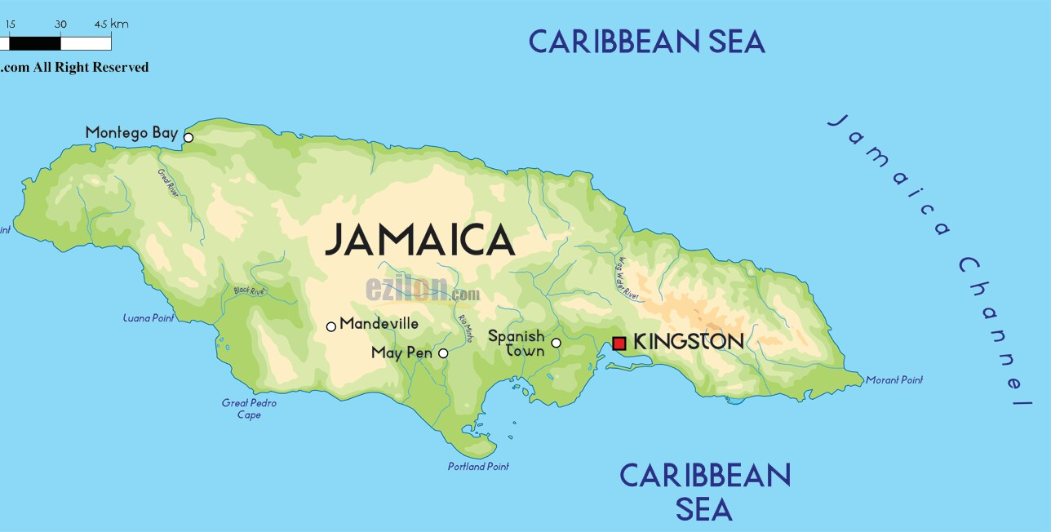
The Map of Jamaica

